Today’s Weather Journal Page
Month: Day: Year:

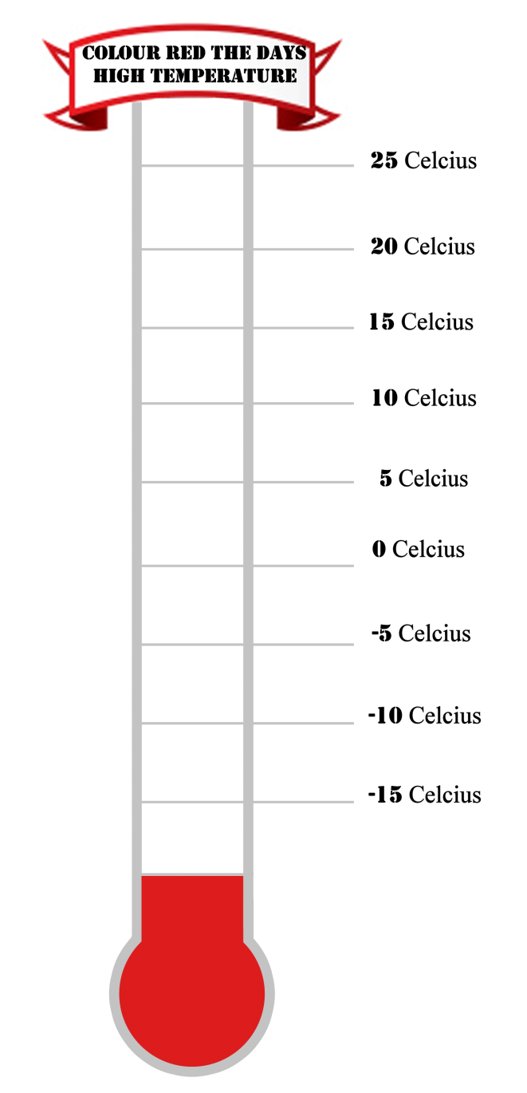
Monday Tuesday Wednesday Thursday Friday Saturday Sunday Today’s weather (Take picture using your tablet and post in this box) Graph the temperature on the thermometer:

What is the temperature?
Are there clouds? If so what type of cloud cover is there?

Freezing Cold Cool Mild Warm
Hot
Cloud Type Review Link

Cirrocumulus
Cirrus
Altostratus
Altocumulus
Stratocumulus
Cumulus
Stratus
Cumulonimbus

The season is:

Describe today’s weather using at least four adjectives to describe it:
(Remember adjectives describe nouns)

