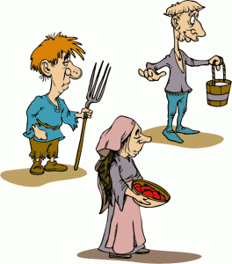 The Medieval Lottery Outline 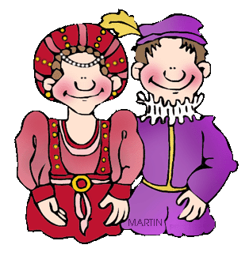
Using the outline information you will collect below, create a three to five minute video using either the class laptops and Pinnacle 17 (Possibility of using chroma keyed backgrounds) or iMovie on your iPad (If you are more comfortable with this) that you can incorporate the information you have gathered from above into a digital story. The video should thoroughly discuss all aspects of your life as the character you received in as much detail as possible. You will dress in costume during the filming of your production in order to get into character. (Costumes are available for each of the medieval characters from the school costume room or you can bring something appropriate to your character from home.) You may also use props you have created or can bring from home as they help relate the digital story of your life in Medieval Europe. You may also choose to use either medieval videos (Discovery Education Account) or Medieval music to enhance and support your presentation. You will each have to create a story board for your digital story in your StoryBoard that account. Each of you completed videos should be saved into your class dropbox folders so they can be easily accessed. Medieval Digital Stories will begin on Monday, February 23rd and proceed until finished.
Your Real Name: ____________________________________
Assigned Role in Medieval Digital Story:_______________________
As you research what life was like for someone of your social status during medieval times, see if you can find the answers to the following questions:
1. What does your home look like? (how big is it, what does it look like on the inside / outside etc.)

2. Might I find Phragmites being used in your home or on the land around it? If so how?

3. Do you own your home? If not, who does?

4. What do your clothes look like? Are they comfortable?

5. Do you have power over anyone else? If so who?

6. Does anyone have power over you? If so who?

7. What is your most prized possession?

8. What do you usually eat for dinner?

9. What do you do for fun? How often do you get to do it?

10. If you have children, what do you expect them to do every day?

11. What tools or implements do you use every day, if any?

12. What is worst thing about your life?

13. What is the best thing about your life?

14. What are your hopes for the future?

15. What do you fear most?

16. How do you and your family stay warm in winter?

17. If your area is invaded by a stronger force that can overtake the current monarchy, will your life change? If so how?

18. How far have you traveled in your life? If you did travel, why did you do so?

19. Describe a typical day at your job.

20. What other interesting things did you learn about the lives of people in your social status within medieval Britain while doing your research?

